|  |
| --- |
|  |
| 新概念 3 册 |
| Lesson21 |

Lesson 21 Daniel Mendoza

**boxing ['bɒksɪŋ]**

**n. 拳击运动**

boxing match boxing gloves

boxing ring boxer

prizefight prizefighter referee

bare [beə(r)] adj. 赤裸的

bare-headed bare-chested

bare-legged bare-assed

bare floor bare mountains with one’s bare hands

Wu Song killed the tiger with his bare hands.

naked

He was naked to the waist. the naked eye

nude

She once posed nude for a magazine.

marquis ['mɑ:kwɪs]

**n. 侯爵**

duke marquis earl

viscount baron aristocracy

aristocrat noble nobleman lord Lord Byron

sir Sir John Hawkwood

technically ['teknɪkli] adv. 技术上；严格地说

a technically brilliant pianist

It is technically possible to produce a human being by cloning. technically (speaking)

strictly speaking

Technically (speaking), the whale isn’t a fish. Strictly speaking, the spider isn’t an insect. **popularity [pɒpju'lærəti]**

adv. 流行，普及；名望

the increasing popularity of organic food

The president’s popularity has declined considerably.

be popular with / among …

She was in love with Donald McGrath, the quarterback on our football team. Football players are always popular with the ladies.

fame

All he thinks about is fame and gain.

renown celebrity name reputation

The restaurant has a very good / bad name / reputation.

famous well-known renowned noted notable legendary

‘the most valiant soldier and most notable leader, Signor Giovanni Haukodue’

He was known to us all as Dickie and his eccentricity had become legendary long before he died.

**celebrated eminent** the most eminent boxer in England **infamous notorious adore [ə'dɔ:(r)]**

v. 非常喜欢，爱慕；崇拜

She adores her only son.

I absolutely adore chocolate.

like love care for fancy

I did not fancy the idea and I reluctantly followed Robert out of the room. be the apple of one’s eye

His youngest daughter is the apple of his eye.

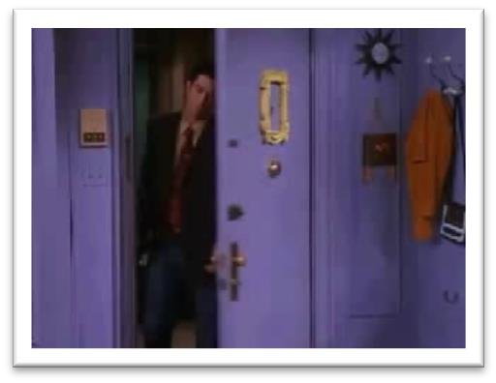Oh look who it is, my husband, the apple of my eye.

fall in love with sb. lose one’s heart to sb.

**be mad / crazy about sb.**

The way to a man’s heart is through his stomach.

carry a torch for sb. have a crush on sb.

Monica had such a crush on him. Yeah, she used to kiss his poster every night before she went to bed.

Oh! I used to do that too!

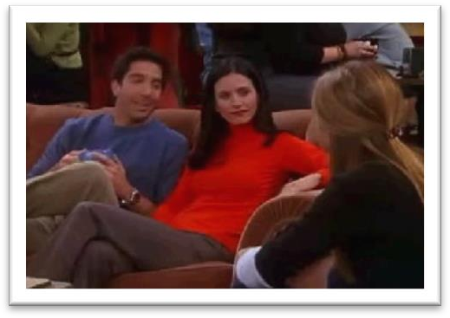

bet [bet]

**v. 打赌**

bet … on …

He bet all his money on the black horse.

I bet = I am certain

Tom's apartment probably costs more than the man's.

The man's place is becoming more expensive.

Her apartment is better than the man's.

She wants to see Tom's new apartment.

M: I’ve just been over to my friend Tom’s new apartment. It's much bigger than my place. W: But more expensive I bet.

Q: What does the woman mean?

Answer: (A) Tom's apartment probably costs more than the man's. you bet = certainly

Pete Waters, RFD Number 1, Chesterton. You know him?

Do I know Pete Waters? You bet I do! He was my roommate in college.

He'll go if the woman goes too.

He doubts he'll be able to go.

He's too tired to go.

He's eager to go.

W: Are you still planning to go to the concert? M: You bet I am.

Q: What does the man say about the concert? Answer: (D) He's eager to go.

academy [ə'kædəmi]

**n. 专科学校，学院**

West Point is a famous military academy. Academy Award (Oscar)

academic academic year academic research

a boxing / basketball / football / volleyball match

It looked as if there would be an exciting race across the Channel.

a car / boat / horse / swimming race contest

a speech / beauty / dance contest open the US Open

tournament championship games

the Olympic Games the Goodwill Games in those days

Though in those days, traveling was not as easy as it is today, steam boats carried thousands of visitors across the Channel from Europe.

In those days wandering minstrels were welcome everywhere.

in those days

**these days nowadays**

**today in this day and age**

These days, people who do manual work often receive far more money than people who work in offices.

with bare fists with naked fists

**with one’s bare hands**

because … since … as…

for … in that… now (that) …

Now that a tunnel has been built through the mountains, the Pass is less dangerous, …….

because of … by reason of… due to … owing to …

**thanks to … on account of …**

She doesn’t like the professor very much.

She doubts class will be canceled.

She doesn’t want to attend the conference.

She wonders whether the professor is an accountant.

M: Do you think professor Smith will cancel class on account of the special conference? W: Not likely.

Q: What does the woman mean?

Answer: (B) She doubts class will be canceled.

know A as B

He soon made a name for himself and came to be known to the Italians as Giovanni Acuto.

He was known to us all as Dickie and his eccentricity had become legendary long before he died.

know A as B refer to A as B

People who work in offices are frequently referred to as ‘white-collar workers’ for the simple reason that they usually wear a collar and tie to go to work.

know A as B refer to A as B

**call A B**

From now on, he will wear a suit all day and others will call him 'Mr. Bloggs', not 'Alf'.

know A as B refer to A as B call A B address A as B

Elizabeth: This is my father, Paul Stevens. Dad, this is Ross Geller. Ross: It’s great to meet you Paul.

Paul: I usually prefer Elizabeth’s boyfriends to address me as Mr. Stevens. Ross: Of course, of course, Mr. Stevens.

However, boxing was very crude, for there were no rules and a prize-fighter could be *seriously injured* or *even killed* during a match.

..., boxing was very cruel, …

..., boxing was very brutal, …

..., boxing was very violent, …

..., boxing was very bloody, …

suffer

… a prizefighter could suffer a serious injury or even be killed during a match. colorful: interesting, exciting, vivid

figure: character, personality

I just wanna be a person, not a personality.

The use of gloves was not introduced until 1860, when the Marquis of Queensberry drew up the first set of rules.

introduce v. 开始推行；开始采用

New safety measures will be introduced next month. You can use my laptop freely.

The use of my laptop is welcome.

draw up 起草

I’ve drawn up a list of candidates that I’d like to interview.

… not … until …, when …

造句：直到毛主席 1949 年宣布 (proclaim) 中华人民共和国成立 (foundation), 中国人民才获得了 (achieve) 解放 (liberation)。

The liberation of the Chinese people was not achieved until 1949, when Chairman Mao proclaimed the foundation of the People’s Republic of China.

Though he was technically a prize-fighter, Mendoza did much to change crude prize-fighting into a sport, *for he brought science to the game*.

do much / a lot / a great deal to … do little to …

**do nothing to … change … into … exchange … for …**

造句：尽管严格地说只是一本书，但圣经在把这个粗鄙的世界变成一个文明世界方面却做出了很大贡献，因为它给人类带来了信仰 (faith)。

Though it is technically a book, the Bible does much to change the crude world into a civilized one, for it brings faith to humanity.

somebody's day

Every dog has his day.

Don’t be disappointed: your day will come.

…, for it enjoyed a high level of civilization. enjoy tremendous popularity

Jay Chou enjoys tremendous popularity among the young. the rich the poor

rich and poor young and old

the rich and powerful alike: in the same way

The climate here is always hot, summer and winter alike. idol / icon

He was an idol / icon of that times.

rise to fame

She first rose to fame as a singer at the age of 16. The rise to fame was swift.

make a name for oneself

He soon made a name for himself and came to be known to the Italians as Giovanni Acuto.

become famous overnight

With the success of their first record, they became famous overnight. attract / draw / catch / capture / arrest *one’s attention / the attention of sb.* **offer to do** 主动提出做某事

In times of peace, when business was bad, Hawkwood and his men would march into a city-state and, after burning down a few farms, would offer to go away if protection money was paid to them.

pupil: apprentice

pupil student

**freshman sophomore**

**junior senior**

**alumnus alumni**

**turn (sb.) against …**

The wicked woman is trying to turn the boy against his father.

… soon became so successful

that Humphries became jealous of him. as to arouse Humphries’ jealousy.

It is / was *clear / obvious / apparent* that …

The rope had been cut, so it was *obvious* that the lamb had been stolen. A match was held at Stilton, and both men fought for an hour there.

…, but he was defeated.

he was beaten.

he failed. he lost.

The public bet a great deal of money on Mendoza, but he was defeated. Mendoza met Humphries in the ring on a later occasion and he lost for a second time. It was not until his third match in 1790 that he finally beat Humphries and became Champion of England.

We finally won that team. X We finally beat that team. √

We finally defeated that team. √ We finally won the game. √

We finally won the prize. √

ring: boxing ring

on / upon the occasion of his daughter’s wedding for a second time = for another time

Everyone went to the funeral, for the 'ghost' was none other than Eric Cox, a third brother who was supposed to have died as a young man.

It was not until his third match in 1790 that he finally beat Humphries and became Champion of England.

champion champagne it was not until … that … and …

造句：直到 1949 年中华人民共和国成立中国人民才最终获得了解放并且成了国家的主人

(master)。

It was not until the foundation of the People’s Republic of China in 1949 that the Chinese people were finally liberated and became masters of the country.

Sir James Clark Ross had obtained a sounding of over 2,400 fathoms in 1839, but it was not until 1869, when H.M.S. Porcupine was put at the disposal of the Royal Society for several cruises, that a series of deep soundings was obtained in the Atlantic and the first samples were collected by dredging the bottom.

it was not until …, when …, that … and ...

造句：直到 1949 年毛主席宣布中华人民共和国成立, 中国人民才最终获得了解放并且成了国家的主人。

It was not until 1949, when Chairman Mao proclaimed the foundation of the People’s Republic of China, that the Chinese people were finally liberated and became masters of the country. **meanwhile**

at the same time (in the) meantime highly successful

**a highly successful play**

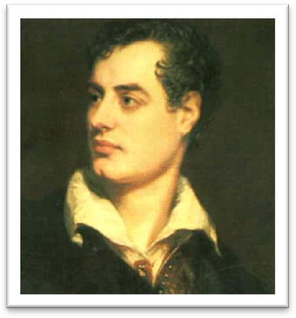 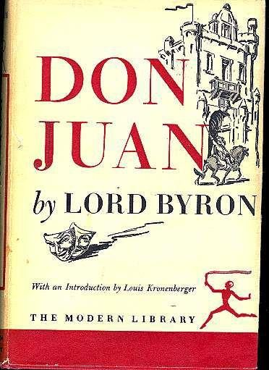

earn enormous sums of money

…, he was so extravagant that he always owed people money. I owe you (one).

How much do I owe you? How much do I owe you?

Well, that'll be eighteen dollars and seventy cents. No charge for the cleanup. It's on the house.